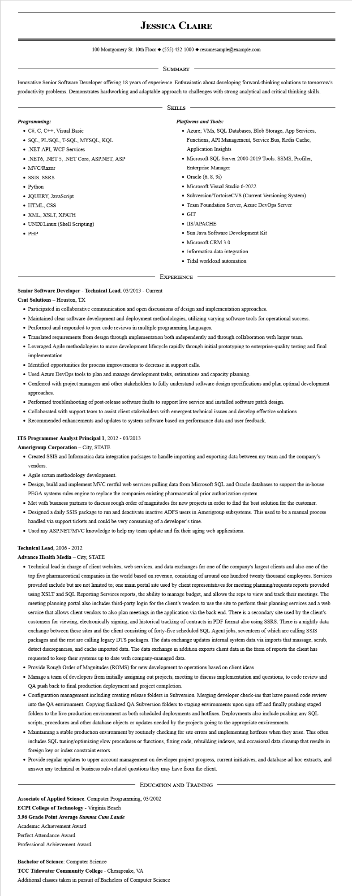
JESSICA CLAIRE
100 Montgomery St. 10th Floor (555) 432-1000◆ resumesample@example.com
SUMMARY
Innovative Senior Software Developer offering 18 years of experience. Enthusiastic about developing forward-thinking solutions to tomorrow's productivity problems. Demonstrates hardworking and adaptable approach to challenges with strong analytical and critical thinking skills.
Programming:
• C#, C, C++, Visual Basic
• SQL, PL/SQL, T-SQL, MYSQL, KQL
⚫ .NET API, WCF Services
• .NET6, .NET 5, .NET Core, ASP.NET, ASP
• MVC/Razor
• SSIS, SSRS
• Python
• JQUERY, JavaScript
• HTML, CSS
• XML, XSLT, XPATH
• UNIX/Linux (Shell Scripting) • PHP
SKILLS
Platforms and Tools:
• Azure; VMs, SQL Databases, Blob Storage, App Services, Functions, API Management, Service Bus, Redis Cache, Application Insights
• Microsoft SQL Server 2000-2019 Tools: SSMS, Profiler, Enterprise Manager
• Oracle (6, 8, 91)
• Microsoft Visual Studio 6-2022
• Subversion/TortoiseCVS (Current Versioning System)
• Team Foundation Server, Azure DevOps Server • GIT
• IIS/APACHE
• Sun Java Software Development Kit
• Microsoft CRM 3.0
• Informatica data integration
• Tidal workload automation
EXPERIENCE
Senior Software Developer - Technical Lead, 03/2013 - Current
Csat Solutions - Houston, TX
• Participated in collaborative communication and open discussions of design and implementation approaches.
• Maintained clear software development and deployment methodologies, utilizing varying software tools for operational success.
• Performed and responded to peer code reviews in multiple programming languages.
• Translated requirements from design through implementation both independently and through collaboration with larger team.
• Leveraged Agile methodologies to move development lifecycle rapidly through initial prototyping to enterprise-quality testing and final implementation.
• Identified opportunities for process improvements to decrease in support calls.
• Used Azure DevOps tools to plan and manage development tasks, estimations and capacity planning.
• Conferred with project managers and other stakeholders to fully understand software design specifications and plan optimal development approaches.
• Performed troubleshooting of post-release software faults to support live service and installed software patch design.
• Collaborated with support team to assist client stakeholders with emergent technical issues and develop effective solutions.
• Recommended enhancements and updates to system software based on performance data and user feedback.
ITS Programmer Analyst Principal 1, 2012-03/2013
Amerigroup Corporation - City, STATE
• Created SSIS and Informatica data integration packages to handle importing and exporting data between my team and the company's vendors.
• Agile scrum methodology development.
• Design, build and implement MVC restful web services pulling data from Microsoft SQL and Oracle databases to support the in-house PEGA systems rules engine to replace the companies existing pharmaceutical prior authorization system.
• Met with business partners to discuss rough order of magnitudes for new projects in order to find the best solution for the customer.
• Designed a daily SSIS package to run and deactivate inactive ADFS users in Amerigroup subsystems. This used to be a manual process handled via support tickets and could be very consuming of a developer's time.
• Used my ASP.NET/MVC knowledge to help my team update and fix their aging web applications.
Technical Lead, 2006 - 2012
Advance Health Media - City, STATE
• Technical lead in charge of client websites, web services, and data exchanges for one of the company's largest clients and also one of the top five pharmaceutical companies in the world based on revenue, consisting of around one hundred twenty thousand employees. Services provided include but are not limited to; one main portal site used by client representatives for meeting planning/requests reports provided using XSLT and SQL Reporting Services reports, the ability to manage budget, and allows the reps to view and track their meetings. The meeting planning portal also includes third-party login for the client's vendors to use the site to perform their planning services and a web service that allows client vendors to also plan meetings in the application via the back end. There is a secondary site used by the client's customers for viewing, electronically signing, and historical tracking of contracts in PDF format also using SSRS. There is a nightly data exchange between these sites and the client consisting of forty-five scheduled SQL Agent jobs, seventeen of which are calling SSIS packages and the rest are calling legacy DTS packages. The data exchange updates internal system data via imports that massage, scrub, detect discrepancies, and cache imported data. The data exchange in addition exports client data in the form of reports the client has requested to keep their systems up to date with company-managed data.
• Provide Rough Order of Magnitudes (ROMS) for new development to operations based on client ideas
• Manage a team of developers from initially assigning out projects, meeting to discuss implementation and questions, to code review and QA push back to final production deployment and project completion.
• Configuration management including creating release folders in Subversion. Merging developer check-ins that have passed code review into the QA environment. Copying finalized QA Subversion folders to staging environments upon sign off and finally pushing staged folders to the live production environment as both scheduled deployments and hotfixes. Deployments also include pushing any SQL scripts, procedures and other database objects or updates needed by the projects going to the appropriate environments.
• Maintaining a stable production environment by routinely checking for site errors and implementing hotfixes when they arise. This often includes SQL tuning/optimizing slow procedures or functions, fixing code, rebuilding indexes, and occasional data cleanup that results in foreign key or index constraint errors.
• Provide regular updates to upper account management on developer project progress, current initiatives, and database ad-hoc extracts, and answer any technical or business rule-related questions they may have from the client.
EDUCATION AND TRAINING
Associate of Applied Science: Computer Programming, 03/2002
ECPI College of Technology - Virginia Beach
3.96 Grade Point Average Summa Cum Laude
Academic Achievement Award
Perfect Attendance Award
Professional Achievement Award
Bachelor of Science: Computer Science
TCC Tidewater Community College - Chesapeake, VA
Additional classes taken in pursuit of Bachelors of Computer Science

